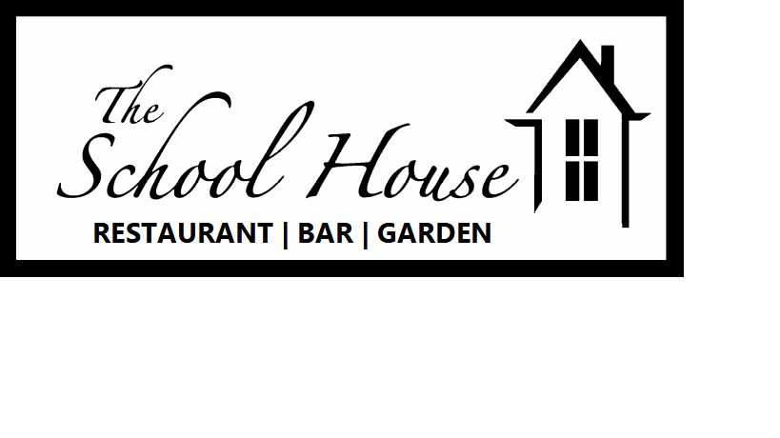
Evening menu
Where possible ingredients have been locally sourced and are home-made. All dishes are cooked to order so please be patient and are served as described below. See the blackboard for daily specials.
FOOD ALLERGIES: Please alert us when ordering if you have any concerns

Starters & Light Bites
Freshly baked bread - Bread baked daily in house with a yeast emulsion £3.95 VE
Marinated mixed olives – Olives marinated in garlic, herbs and citrus £3.95 VE GF
Soup of the day – Changes daily using the finest seasonal ingredients £5.50 VE GFO
The School House grazing platter - A combination of our own treacle cured ham and smoked beef brisket, fresh bread, house pickles, olives and cheeses
£6.95 per person (min 2 people) GFO
Mojito Crab – Crab claw meat served with a compressed watermelon, lime and
cucumber salad £6.95 GF
Merguez scotch egg – Eastern spiced lamb scotch egg with baba ganoush and pink pickles £6.50
Wild mushroom flatbread – Stone baked flatbread topped with wild mushroom and Shropshire blue cheese with watercress and a balsamic glaze £5.95 V VEO
Smoked beef brisket flatbread - Stone baked flatbread loaded with house smoked beef brisket with mozzarella, pickles and watercress £6.25

Saladé
Crispy beef noodle – Thinly sliced roast beef with Asian slaw, aromatic herbs, garden greens, peanut soy dressing and crispy rice noodles £ 12.95 GF
Summer budda bowl – Grilled corn succotash with garden greens, fresh herbs, pink pickles, baba ganoush, freshly baked bread and a peach dressing £11.95 VE GFO
Add roast chicken to your bowl for £3
Lobster ceaser – Lobster meat tossed with romaine lettuce, roasted garlic croutons and crushed black olives, topped with classic ceaser dressing and a parmesan crisp £19.95 GFO

Grill
8oz Sirloin steak £19.95 | 10oz Rump steak £16.95 | 8oz Fillet £26.95 GF
All steaks are cooked to your preference and are served with;
hand cut triple cooked chips, vine roasted tomatoes and portobello mushroom
Add whole lobster tail £19.95 king prawns £4.95 Steak sauce £2.95
The Schoolhouse Burger - Hand pressed beef patty with BBQ pulled pork, cheddar, crispy onions, pickles and burger sauce in a brioche bun with skin on fries £12.95 GFO
Italian Chicken focaccia Burger - Chicken breast coated in parmesan breadcrumbs with mozzarella, pesto and Parma ham in freshly baked focaccia with skin on fries £13.95 GFO

Mains

8oz Pork Rib eye – Charred locally sourced pork rib eye served with silky mash, garden greens and a blue cheese walnut butter £13.95 GF
Roast Vegetable Stromboli - Roasted bell pepper, wild mushrooms and spinach rolled in fresh dough with pesto, vegan mozzarella and marinara sauce served with a tomato and chic pea salsa £12.95 VE
Blackened Cajun Pollock – Pollock fillet coated in cajun spices served with a tomato lime salsa, sautéed new potatoes and fresh herbs £15.95 GF
Roasted Chicken Breast - Pan roasted Churchill farm chicken with wild garlic mash, pancetta crisps, blue cheese velouté and garden greens £13.95 GF
Veal Schnitzel - Veal escalope coated in a panko crumb and quick fried in beef dripping served with a lemon caper butter, green beans and triple cooked chips £14.95
Smoked Beef Brisket - Low and slow smoked beef brisket with grilled corn succotash, ceaser wedge salad, slaw and skin on fries £14.95 GF

Sides - Seasonal veg|House salad|Triple cooked chips|Fries|Onion rings £2.95

Desserts

The Schoolhouse Brownie – Dark chocolate brownie with a pistachio ice cream £6.95 VEO
Loaded cheesecake - Vanilla cheesecake loaded with lemon, berries and passion fruit £6.95 V
Creme Brulee - Classic crème brulee with roasted peaches and shortbread £6.50 GFO
Berrys and cream - Textures of summer berries and cream with meringue £5.95 GFO V
Cheese and Biscuits - Mature cheddar, Shropshire blue and smoked Brie served with crackers, house pickles, green tomato relish and grapes £6.95 per person GFO V

GF - Gluten Free GFO – Gluten free option V – Vegetarian VE – Vegan VEO – Vegan option

