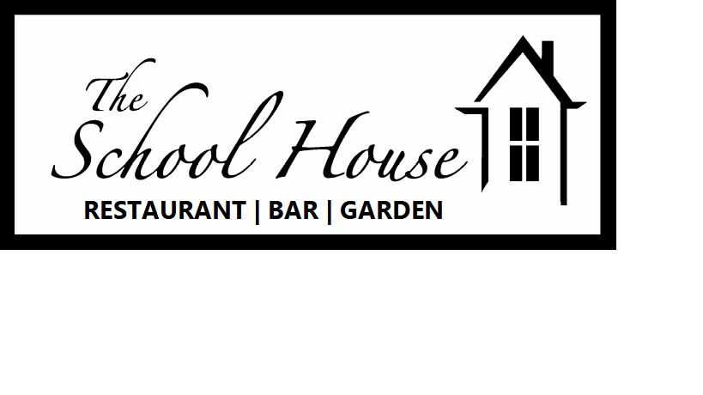
Sunday lunch menu
Where possible ingredients have been locally sourced and are home-made. All dishes are cooked to order so please be patient and are served as described below. See the blackboard for daily specials.
FOOD ALLERGIES: Please alert us when ordering if you have any concerns
2 courses £15 or 3 courses £18
Starters
Soup of the day – Changes daily using the finest seasonal ingredients VE GFO
Treacle cured ham – Ham cured in house with roasted peach and wedge salad GF
Classic prawn cocktail – Greenland prawns on a bed of little gem, tomato and cucumber topped with marie rose sauce GF
Wild mushroom flatbread – Stone baked flatbread topped with wild mushroom and Shropshire blue cheese with watercress and a balsamic glaze V VEO

Mains
Roasted topside of Derbyshire beef
Roasted Nottinghamshire loin of pork
Roasted Yorkshire chicken (½ or full)
Nut and mushroom roast VE GF
All roasts are served with Yorkshire pudding, roast potatoes, mashed potatoes, seasonal vegetables and pan gravy GFO

Sides – Cauliflower cheese|Pigs in blankets|Stuffing|Veg|Mash|Roasties £2.95

Desserts

The Schoolhouse Brownie - Hot Dark chocolate brownie with fresh cream VEO
Loaded cheesecake - Vanilla cheesecake loaded with summer berries V
Classic Eaton mess - Strawberries with crème chantilly and meringue GF V
Cheese and Biscuits - Mature cheddar, Shropshire blue and smoked Brie served with crackers, house pickles, green tomato relish and grapes £6.95 per person GFO V
GF - Gluten Free GFO – Gluten free option V – Vegetarian VE – Vegan VEO – Vegan option

